12 March 2016

1:59 AM

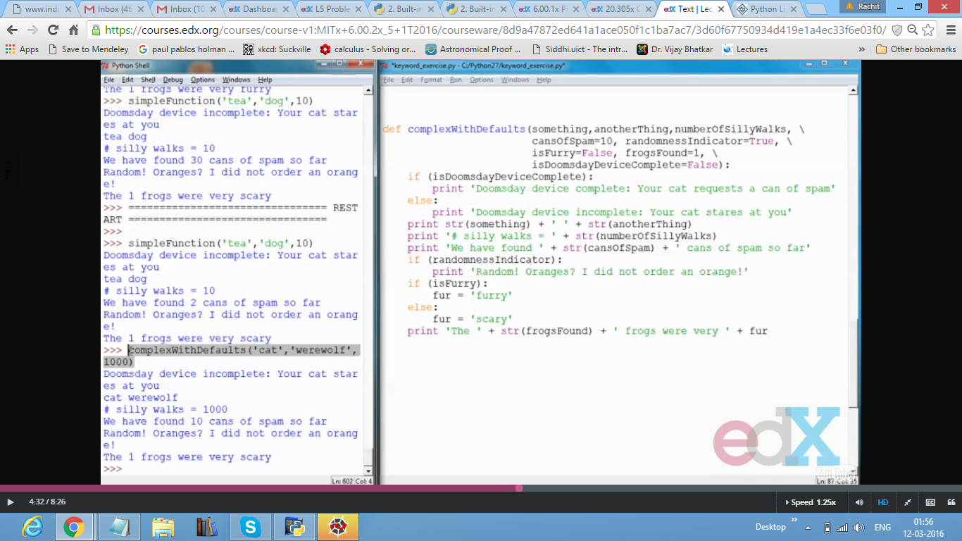

This is a discussion about simplifying complex functions by specifying certain default parameters in the function itself. These parameters can be manipulated by specifying the name of the parameter followed by its new value.

For eg.

Def compl_funt(x,y,z,t=10)

This will set default t variable value as 10 for all problems, but I can change it any time I want it

By calling as compl_funct(2,3,4,t=2) etc. for t=2